

**Synopsis**

**On**

**Landscape Generator**

**By**

Yash S. Desai 20ST114281071

Harsh U. Patil 20ST114281081

Amol D. More 20ST114281080

Shivraj M. Patil 20ST114281077

Under the guidance of

**Mrs. Mrunal Deshpande.**

School of Computer Science and Engineering

**2021-2022**

# INTRODUCTION

We are working on a computer game for generating a realistic landscape.

Our algorithm inspires by geological processes.

Firstly, we have started our algorithm by generating a simple flat landscape.

It modifies ups and downs of landscapes repeatedly.

The algorithm starts with a flat landscape and repeatedly modifies it by lifting or lowering continuous blocks, thus forming lifted blocks and lowered blocks.

The blocks to be lifted or lowered are selected at random.

Your task is to interpret any sequence of such modifications and output the resulting landscape.

# OBJECTIVES

The main Objective of Landscape generator is-

1. To generate a realistic landscape for a computer Game.

1. To interpret any sequence of such modifications like the lifting or lowering landscape outputs.

1. The main goal is to calculate the result height of every position of on our line.

# EXAMPLE

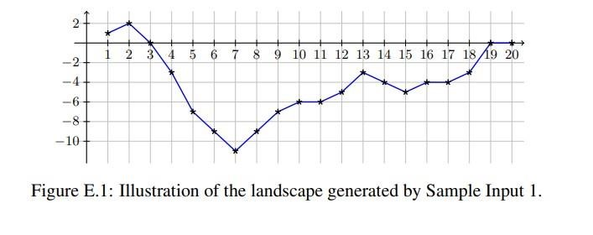

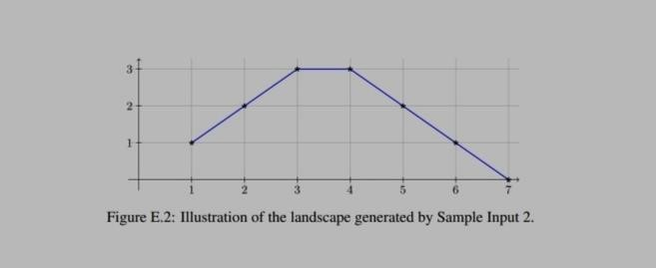

R: Raise – increase the height by 1 at all points between x1 and x2 inclusive.

D: Depress – decrease the height by 1 at all points between x1 and x2 inclusive.

H: Hill – add a new linearly shaped hill between x1 and x2.

V: Valley – add a new linearly shaped valley between x1 and x2.

The first line of input contains two integers n and k, where n (1 ≤ n ≤ 200 000) is the number of points, and k (0 ≤ k ≤ 200 000) is the number of modifications.

The n points along the x-axis are numbered from 1 to n. The next k lines describe the modifications. Each line contains one characters and two integers x1 and x2, where c (one of R, D, H or V) designates the operation and x1 and x2(1 ≤ x1 ≤ x2 ≤ n) specify its parameters.

Output n lines, where the i th line contains the height at point i after applying all modifications in the given order.

# METHODOLOGY

The below flowchart shows the methodology of the landscape generator:

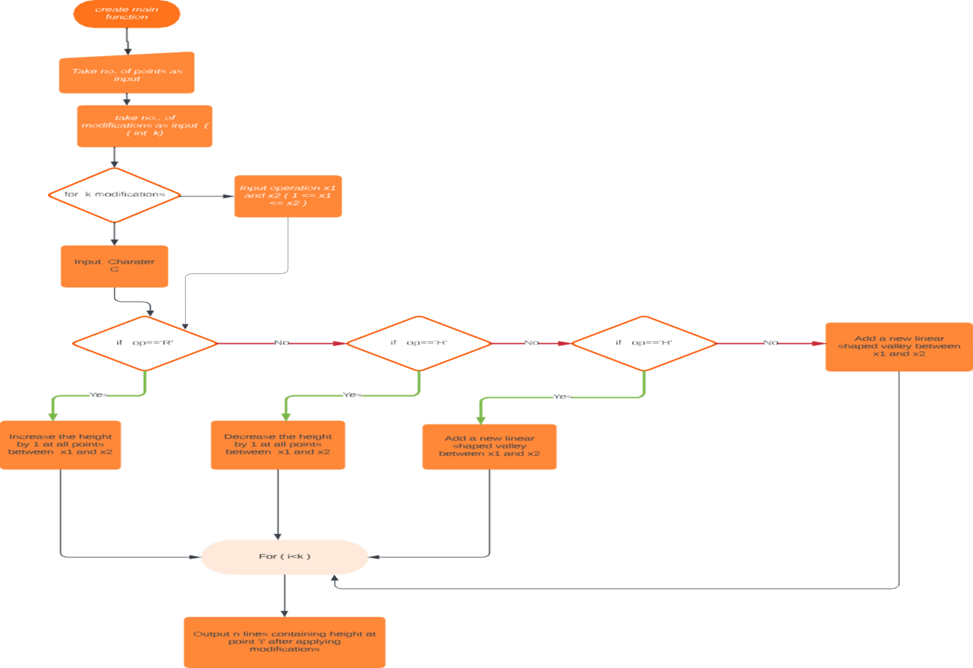

**5) LITREATURE SURVEY**

1. C++ Basic Concepts

<https://www.javatpoint.com/cpp-tutorial>

1. C++ Control Statement

<https://www.javatpoint.com/cpp-tutorial>

## **C++ IF-else Statement:**

The C++ if-else statement also tests the condition.

It executes if block if condition is true otherwise else block is executed.

# C++ For Loop:

The C++ for loop is used to iterate a part of the program several times.

# C++ While loop:

In C++, while loop is used to iterate a part of the program several times.

If the number of iteration is not fixed, it is recommended to use while loop than for loop.

1. Landscape Generator

<https://www.youtube.com/watch?v=B6yNhtNehE0>

# TECHNOLOGY DESCRIPTION

We are implementing this problem statement with the help of c Language



1. **REQUIREMENTS**

◦ **Software requirements:**

C++ compiler

◦ **Hardware requirement:**

Processor: Intel i3/i5/i7

RAM minimum 4 GB

Hard disk minimum 15 GB

System type 32bit Operating System

Internet connection

**REFERENCES**

[1] [https://icpc.global/worldfinals/problems/2020+ACM](https://icpc.global/worldfinals/problems/2020+ACM-ICPC+World+Finals/icpc2020.pdf)-[ICPC+World+Finals/icpc2020.pdf](https://icpc.global/worldfinals/problems/2020+ACM-ICPC+World+Finals/icpc2020.pdf)

[2] <https://www.youtube.com/watch?v=B6yNhtNehE0>